Project Development Phase

**Model Performance Test**

|  |  |
| --- | --- |
| Date | 10 November 2022 |
| Team ID | PNT2022TMID35444 |
| Project Name | Classification of Arrhythmia by Using Deep Learning with 2-D ECG  Spectral Image Representation |
| Maximum Marks | 10 Marks |

**Model Performance Testing:**

|  |  |  |
| --- | --- | --- |
| **S.N**  **o.** | **Parameter** | **Values** |
| 1. | Model Summary | We are creating a model for predicting 6 classification of ECG images. |
| 2. | Accuracy | Training Accuracy - 100%  Validation Accuracy - 99.8% |

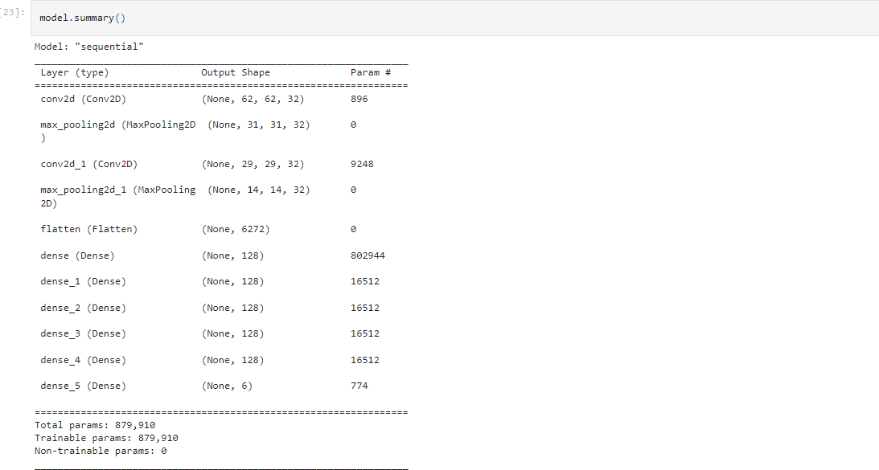Screenshots: 1.Model Summary

* 1. **Training Accuracy**

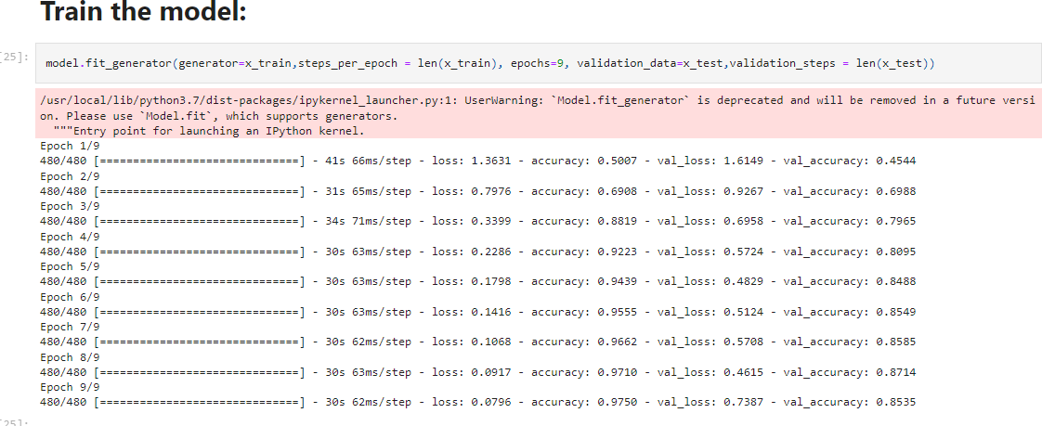

* 1. **Validation Accuracy**

